Buy and Hold Benchmark Strategy
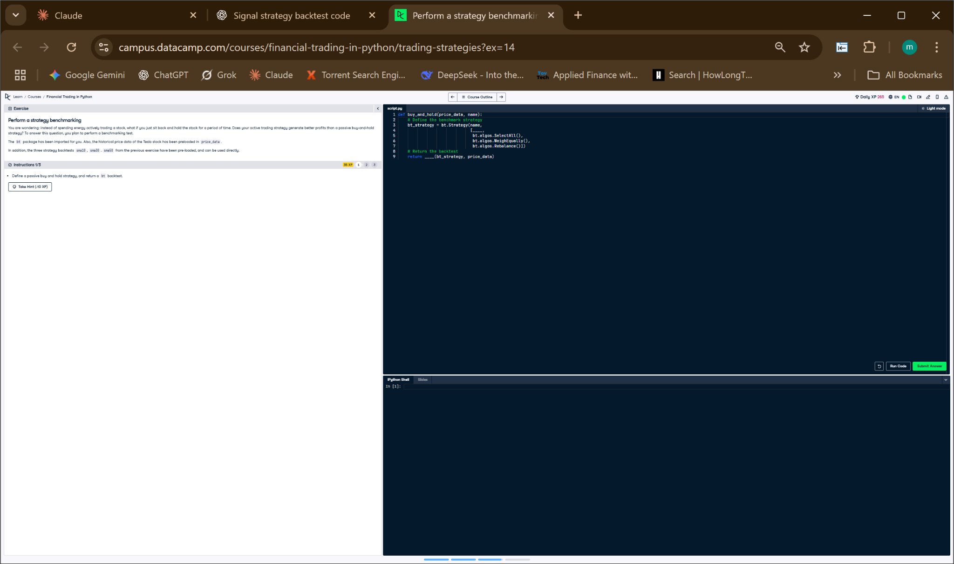

Python Code
def buy_and_hold(price_data, name):
# Define the strategy
bnh_strategy = bt.Strategy(name,
[bt.algos.SelectAll(),
bt.algos.WeighEqually(),
bt.algos.Rebalance()])
# Return the backtest
return bt.Backtest(bnh_strategy, price_data)

Explanation
This function defines a passive buy-and-hold strategy by selecting all stocks, assigning them equal weight, and rebalancing once. It mimics a basic long-term investment without trading. The function returns a backtest object so its performance can be compared to more active strategies.

